GD Image Generator Quality and Speed Test

Image quality (for jpeg and png)
This experiment test image generate function imagepng and imagejpeg with different source images and parameters (quality number and filter applied). Check the detailed results in PHP_GD_Generate_Image.xls.
Generally speaking, when generating JPEG, the higher quality (rank from 1-100, 100 as best) required, the larger file size we will get and longer execution time to proceed.
- Visually: JPEG with different quality has significant difference in appearance, subjectively speaking, anything under quality 60 is hardly acceptable.
- File size: High quality increase file size a lot, 90 increase file size by 40%-50% to 80 and 100 increase file size by more than 250% to 90. For high resolution (1200px width, 72dpi) image, 80 quality image is 100-200kb and 90 quality is 200-400kb, which are in acceptable range of file size. 100 quality is 500kb-1.2mb, seems too big.
- Execution time: Higher quality also increase execution time a lot (percentage wise speaking). 90 increase execution time by 5-10% from 80; 100 increase 20-40% from 90. Nevertheless, in localhost, it takes around 0.1s to generate 100 quality high resolution (1200px width, 72dpi) image and in production server, it takes around 0.01s. So we do not need to consider this factor in choosing image optimise option.
So the best optimize option is probably somewhere around 80 (some article suggests 75 is a common standard for web use images).

PNG, on the other hand, has the lowest generation time when apply highest quality (no filter and best quality number 0).
- Visually: Different quality (rank from 0-9, 0 as best) and different filters ('PNG_NO_FILTER', 'PNG_FILTER_NONE', 'PNG_FILTER_SUB', 'PNG_FILTER_UP', 'PNG_FILTER_AVG', 'PNG_FILTER_PAETH', 'PNG_ALL_FILTERS') does not change image that much. The highest compressed image is merely little bit dull than the no compression version.
- File size: When 0 (no compression) applied, filters do not seem to affect image file size at all and the image generated seems to be much bigger than compressed version (for one extreme example, it's more than 500% size of the 2nd best - quality 1 and no filter applied). It's normally bigger than the source image, so there's hardly any point to ever use this quality grade at all. For the rest, 1-9 and with different filters, only affect image size a little bit, Quality 9 with all filters is normally around 70%-80% size of Quality 1 with no filter. Comparatively, there is a big difference in file size between whether to apply a filter. For certain big images (images with large area of same/similar colour?), apply one (any one) filter immediately drop the file size by about 20%. However, for some other, it might actually increase the file size. For an exceptional case, a 70x70 png icon, Quality 1 with no filter is actually smaller than Quality 9 with all filters, filters actually increase file size by about 40%. For high resolution (1200px width, 72dpi) image, highest compressed PNG (9 all filters) takes 1.2-2MB and lowest compressed PNG (1 no filter) takes 1.6-2.5MB.
- Execution time: Higher compression rate (lower quality) also increase the execution time a lot. Apply filter on high compression level seems to increase execution time dramatically. For high resolution image (1200px width, 72dpi), quality 9 (maximum compression) with all filters takes 1-2 seconds to execute while quality 1 (minimum compression) with no filter only take around 0.1 second.
Overall, DO NOT apply big png pictures, they are not suitable for websites. Only use small ones and only use them when you need a transparent or half transparent effect. The best optimize options are around Quality 7 with no filter and Quality 1 with a single 'PNG_FILTER_UP' or 'PNG_FILTER_SUB' filter (in my limited experiment, 'PNG_FILTER_UP' seems perform best in speed among all filters).

Image resize, imagecopyresize VS imagecopyresampled
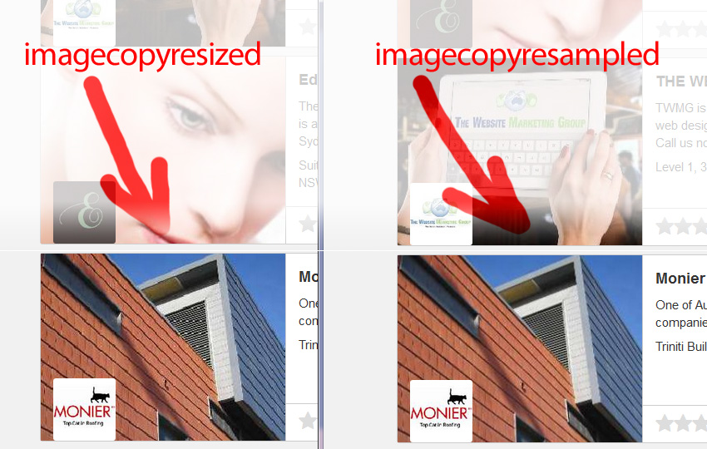
First, quality wise, imagecoopyresampled is much better than imagecopyresized, so there's not really an option here. All resize should use resampled not resized. Nevertheless, we are conducting an experiment for the whole image generation process. So, I am going to do a speed test to see the server execution time difference.
For 10 JPEG images and 70 PNG images we generated from previous experiment, we use both resize and resample function to resize them. Consider image generate process is not only resizing, but also steps like create gd image resource object from source file and write the image out to a file, in the experiment I also record those time to get better idea of whole time spending process.
Compare the experiment result data in PHP_GD_Generate_Image.xls, we can see that indeed imagecopyresized is much faster than imagecopyresampled. To resize a 1200x900 image source to 400x300, imagecopyresized takes 1-2ms while imagecopyresampled takes 20-30ms. Image file I/O speed varies a lot on different server environment though, in my localhost, it takes 0.03-0.09 second to read and write one file while production server only take 0.005-0.01 second.

